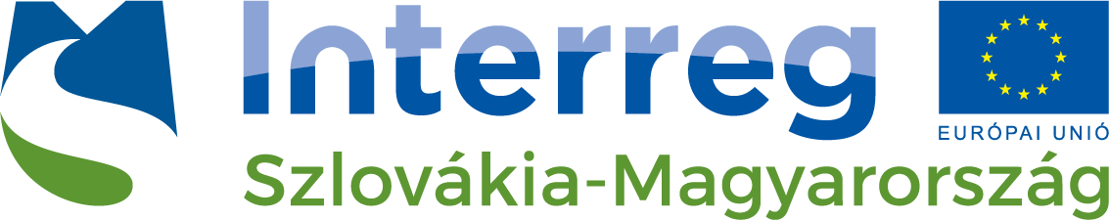
Hungarian National Trading House in Budapest, Partner of the Interreg HUSK EYES project cordially invites you to its interactive training focusing on the usefulness of international marketing for expanding abroad– 10th October, 2018

International marketing is the application of marketing principles in more than one country, by companies overseas or across national borders. International marketing is based on an extension of a company’s local marketing strategy, with special attention paid to marketing identification, targeting, and decisions internationally.

As technology creates leaps in communication, transportation, and financial flows, the world continues to feel smaller and smaller. It is possible for companies and consumers to conduct business in almost any country around the world thanks to advances in international trade.
However, globalization has created just as many challenges as opportunities for brands that venture overseas. As consumers have so many more options for similar products, companies must ensure that their products are high in quality and affordability. Additionally, these products cannot be marketed identically across the globe.

In this event, the Absolvo Consulting expert Iván Gyurácz Németh will explain how to best prepare for international marketing when traveling abroad.
The following themes will be discussed:
- International Marketing- introduction
- Basics of go-to –market strategy
- Market research –how to make the most effective
- Sales and marketing channels
- Case Studies
The expert could also be available for one-on-one consultations after the presentation.
The trainer will be : Iván Gyurácz Németh
Company Name: Absolvo Consulting

Iván Gyurácz Németh as Head of the Internationalisation and Business Development Department of Absolvo, Iván’s key areas of expertise are strategic and international marketing, with a strong focus on the internationalisation of companies. He advises companies in developing their go-to-market strategies on a daily basis and takes part in the actual implementation in a hands-on manner. Generating new customer leads, building up sales processes and structures for startups or participating in the international sales of a scaleup are all integral parts of his job.

Iván is a Board Member of the Hungarian Foreign Trade Association. He is also an experienced trainer, regularly holding presentations both in Hungarian and in English on the subjects of international marketing, sales & business development and the internationalization of SMEs.
He is a lecturer of international marketing at the Metropolitan University’s Strategic Marketing Executive MBA course.

Project registration number: SKHU/1601/4.1/103
Language of the event: EN
Date: 10 October 2018, 10:00 – 16:00
Venue: Budapest, Corvin Hotel Budapest (H-1094 Budapest, Angyal street 31. )
contact: corvin@corvinhotelbudapest.hu
GPS coordinates: 47.483467,19.070331

Participation at the workshop is free of charge but registration is required!
Please note, that number of participants at the training is limited up to 25 to provide interactivity. Applications will be accepted in order of arrival.
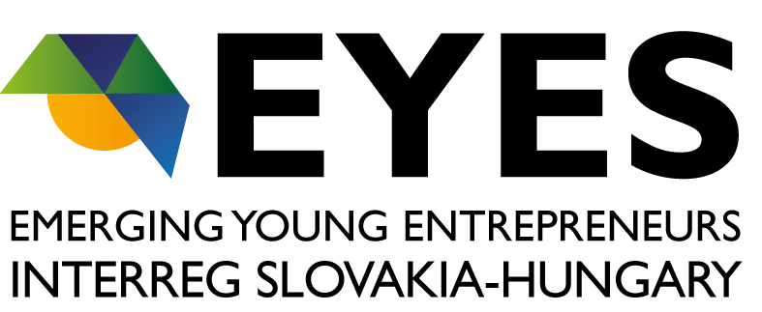
Please indicate your intention to participate by 08 October 2018 at the latest by completing the online registration form below.

Programme website: http://www.skhu.eu/

Project website: http://bvk.hu/eyes/
The content of this invitation does not necessarily represent the official position of the European Union.
Further information:
Veronika HERPAI-SZABÓ Adrienn KÖVÉR-VÁRADI
project coordinator SME export training advisor
e-mail: szabo.veronika@tradehouse.hu e-mail: varadi.adrienn@tradehouse.hu
phone: +36 (20) 335 9720 phone:+36 (20) 232 06 84

International marketing workshop
EYES – INTERREG draft programme

Date: 10 October 2018, 10:00 – 16:00
Venue: Budapest, Corvin Hotel Budapest (H-1094 Budapest, Angyal Street 31. )
contact: corvin@corvinhotelbudapest.hu
GPS coordinates: 47.483467,19.070331

9:30-10:00 | Registration
10:00-11:30 | SESSION I  1. introduction – international marketing  - what is marketing, what is the difference between international and „local” marketing?  - sales vs marketing  - the role of marketing within a company
2. basics of a go-to-market strategy
- what (do we offer)? – product, value proposition
- to whom?
- how (do we sell)? – sales and marketing channels

3. WHAT do we offer?
- product vs value proposition
- concept of customer centricity
- definition of USPs - workshop

11:30-11:45 | Coffee break
11:45-12:45 | SESSION II  4. WHAT do we offer? cont’d…  USP workshop
5. TO WHOM do we offer/sell?
- target group definition
- concept of STP

12:45-13:45 | Lunch
13:45-14:45 | SESSION III  6. Market research  - what do we need to research?  - how? some practical advice on how to (and how not to) conduct a market research  - concept of Porter’s five forces  - target market selection
14:45-15:00 | Coffee break
15:00-16:00 | SESSION IV  7. sales and marketing channels  - sales vs marketing-driven strategy  - direct vs indirect selling  - HBR seven rules of distribution  - conversion, KPIs, etc.
16:00-16:30 | Q&A , conclusions

During all sessions, partcipants will be required and asked to actively take part in the discussions! By the end of the day they will get acquainted with some tools and practices that will help them to design and implement their market entry strategy, tailor-made to the product/company/business idea. All topics will be supported by examples and experience from real companies.

