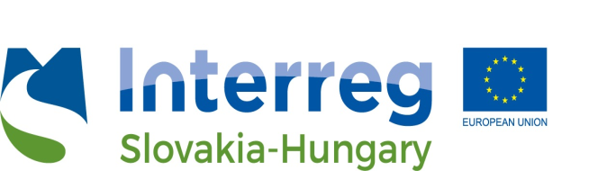

PRESS RELEASE

„InnoService” Cross-border Innovation Service Portfolio

The Chamber of Commerce and Industry for Borsod-Abaúj-Zemplén Country has started the implementation of the 16-month-long tender called „InnoService” Cross-border Innovation Service Portfolio, whose consortium is headed by the Chamber of Commerce and Industry of Banská Bystrica. From the Slovakian side the Chamber of Commerce and Industry of Slovakia, Kosice branch participates in the project with two other Hungarian chambers, Chamber of Commerce and Industry for Nógrád and Heves Country.

The main objective of the project is to promote the cooperation effectiveness of the Slovak and Hungarian regional of chambers of commerce and industry as well as employees' knowledge and experience on individual innovation services for businesses. These information related to the R & D infrastructure have been collected by the chambers in the regions of Southeast Slovakia and Northeastern Hungary, and then keep all of these informations continuously accessible and available with a newly developed mobile app and web site to all those interested. The catalog is also available online at the following website: https://inno-service.eu/hu/

The total budget of the project is EUR 162 174,60, which is co-financed by the European Regional Development Fund (ERDF) and implemented under the Interreg V-A Slovakia-Hungary Cooperation Programme. Details: info@skhu.eu, www.skhu.eu

The most important activities of the "InnoService" project included the mapping of regional knowledge providers, innovative service organizations, universities, research and development organizations, companies, and then the elaboration of the cross-border innovation service portfolio in Slovakian, Hungarian and English language by data processing. Each project member hosts a partner meeting and a thematic workshop on a predetermined topic. The first thematic workshop was organized in Eger,with the topic of product development. The second thematic workshop on technology transfer and start-ups was held in Kassa. In Bánk, the internationalization of companies was the theme, and in Miskolc, a workshop organized around innovation strategies. The knowledge gained at the workshops is provided by the chambers in the form of advisory services to the companies.

Service providers and developing companies can introduce themselves into business in the following industries and could initiate / can initiate bilateral negotiations about cooperations:

- Meeting of timber industry and forestry professionals – Zvolen, 18 September 2018.
- Mechanical and IT-systems for the mechanical industry – professionals meeting – Eger, 4 October 2018.
- IT professionals’ meeting – Košice, 25 October 2018.
- Meeting of metallurgical industry professionals – Salgótarján, 20 November 2018.

On 4th of December there will be a meeting of automotive industry professionals – in Miskolc, organised by the Chamber of Commerce and Industry for Borsod-Abaúj-Zemplén Country. In the framework of this event automotive companies can learn about the knowledge providers of the automotive industry, their services and the companies can know each other.

The project end sin January of 2019 by a grand closing conference.

Further information:
Livia Lebenszky, Chamber of Commerce and Industry for Borsod-Abaúj-Zemplén Country Tel: +3646501878, Mobil: +36202237781
E-mail: lebenszky.livia@bokik.hu

The content of this press release does not necessarily reflect the position of the European Union.

