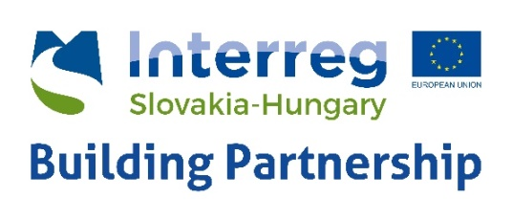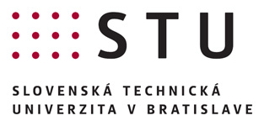

Invitation and Programme

Institute of Management of the Slovak University of Technology (IM STU) in Bratislava, Partner of the Interreg SKHU EYES project announces workshop on correct and efficient blogging for startups in co-operation with the STU Incubator of Technology (STU UTI) in Bratislava – 12 June, 2018

Our invited expert Ms. Marie Stracenská will introduce how to best prepare and use your company blog. You will not be writing blogs there but we will be jointly reading and analysing some blogs. It is not going to be a lecture, more a workshop with active participation of the audience. Some tasty refreshments will not be missing as well.
Topic: Ten commandments of good blogging
The following themes will be discussed:
- What we like about good blogs –inspiration,
- Briefly about ceative writing,
- How ro cope with headlines,
- Blogs in service of business

The trainer will be Ms. Marie Stracenská
Firm: Reknown journalist, PR manager of one of the Slovak political parties

Ms. Marie Stracenská has had extensive experience from work with the Slovak TV (STV), TA3 and TV Markíza in Slovakia. Currently she works as a PR manager of one of the Slovak political parties, lecturer of the Sokrates Institute, and she is a mom of twins as well. She has experience from development of presidential campaign and she works a lecturer and consultant for various organisations, among other for the PDCS and Restartup.

Date: 12 July 2018, 9:00 to 11:00 a.m.
Venue: Univerzitný technologický inkubátor STU, 1st floor, room nr. 102
Pionierska Street 15, 831 02 Bratislava
Web: www.inqb.sk E-mail:info@inqb.sk

The workshop is free but registration is required!
Registration by e-form: pomocou elektronického formulára by 11 July 2018, 3 p.m. at the latest.

