The 9th Be Smart startup competition – call for applications

The 9th Be Smart competition will be organised by the Budapest Enterprise Agency (BEA) to provide the most promising startups with the opportunity to present themselves and network in Hungary and abroad.

BEA’s Be Smart competitions have been key to the success of many Hungarian startups. Tibor Dobai, GIS specialist at Route4U, former winner of Be Smart competitions commented:
‘We have taken part in several Be Smart startup competitions organised by BEA and have won business trips to Ireland, Germany, Spain, Portugal and even France. By now, we have accomplished at least one pilot project in each of these countries and in the capitals we have already managed to work in close cooperation with the city administration or we are going to do so in the near future. I consider these results as 100% success.’

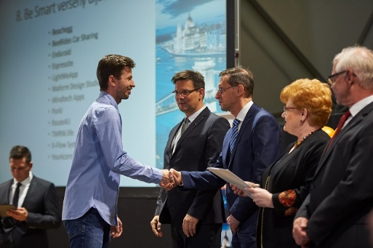

Startups awarded in the competition will win the opportunity to:

- attend FutureScope, one of the most dynamic forums of the tech world, taking place in Dublin on the 28th March 2019;
- register for the Rheinland Pitch on Danube semi-final in Hungary. The winner of the semi-final will be awarded with the opportunity to participate in Germany’s grandiose startup competition, the Rheinland Pitch Düsseldorf Final on the 3rd April, 2019;
- under the aegis of the Interreg V-A Slovakia-Hungary Cooperation Programme’s EYES project which is led by the Budapest Enterprise Agency, the consortium of Slovak and Hungarian institutions co-operate and launch a special competition exclusively for Slovak and Hungarian applicants and the winners will have the opportunity to exhibit at the Budapest Startup Forum on the 4th April, 2019 as the side event of think.BDPST as well as to exhibit and participate in the competition at the international think.BDPST Start-up Expo;
- present themselves at the Smart Cities Summit in Lisbon on the May 21st-23rd, 2019.

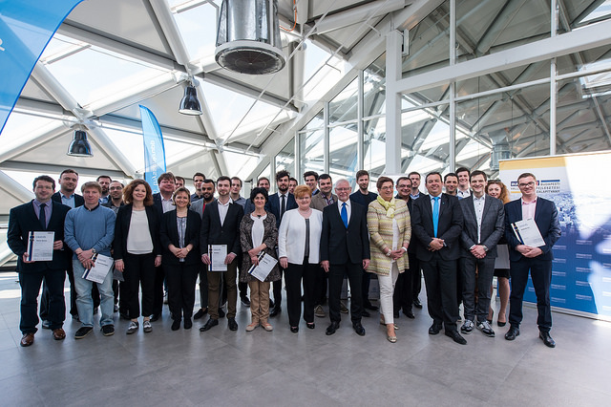

More about the prizes:

FutureScope - Dublin:

Date: 28 March, 2019

Contributions by the organisers to 4 winners:
- free participation, exhibition and networking at the event and rich delegation programme
- B2B meetings
- free accommodation (1person/startup)

Contribution by the 4 winner startups:
- reservation and payment of travel

Rheinland Pitch on Danube – semi-final in Budapest:

Date: 3 April, 2019

4 winners selected by the jury will enter the semi-final held on the 3rd of April, 2019 in Budapest. The absolute winner will have the opportunity to participate in the Rheinland Pitch Düsseldorf Final on the 24th June, 2019.

Startup Budapest Forum within the framework of the EYES project supported by the Interreg V-A Slovakia-Hungary Cooperation Programme and think.BDPST Start-up Expo:

Date: 4-5 April, 2019

Contributions by the project consortium members to 6 winners (3 Hungarian and 3 Slovak):
- free exhibition and presentation at the Startup Budapest Forum on the 4th April, 2019
- free exhibition and presentation at think.BDPST Start-up Expo on 4th-5th April, 2019
- participation in the international startup competition within the framework of think.BDPST on the 5th April, 2019

Contribution by the 6 winner startups:
- presentation materials, publications, prototypes and all relevant information for the exhibitions

Subject/Topic:
- no restriction, but preference for smart home, mobility and cybersecurity solutions

Smart Cities Summit – Lisbon:

Date: 21-23 May, 2019

Contributions by the organisers to the 4 winners:
- free participation and exhibition at the Hungarian booth of Smart Cities Summit
- presentation and networking opportunities at the event organised by the Hungarian Embassy
- free accommodation (1person/startup)

Contribution by the 4 winner startups:
- reservation and payment of travel

Conditions for participation in the competition:

Participating startups are expected to have a prototype. There is no restriction on topics, except for the Smart Cities Summit in Lisbon, which focuses on innovative smart solutions in the broader sense of smart city.

Deadlines:
1st round:
The written applications are to be submitted until: 28 January, 2019, 12 p.m.
Please fill in the application form to register. Please also send a one-pager in English and your company logo to jova.timea@bvk.hu.
2nd round:
Pitch your business idea in English in 3 minutes on 5 February, 2019. (Further details will be available later.)

Winners will be notified in writing.

Further information: Tímea Jova, phone: +36 30/484 0869 jova.timea@bvk.hu

