Invitation
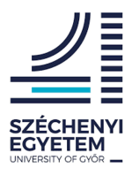
Within the framework of the Interreg European Union tender, we cordially invite you to the lecture series of the conference organized on March 30, 2021 at National Agricultural and Food Centre (NPPC) Bratislava.

The topics of the presentations are: Evaluation of quality and production and raw materials with specific technological properties and the Planning of sustainable nutrient supply during cultivation of plants.
Conference venue:
National Agricultural and Food Centre (NPPC)
Hlohovecká 2, 951 41 Lužianky, Slovak Republic &
Széchenyi István University
Faculty of Agriculture and Food Science

Date: 30/03/2021 09⁰⁰ – 11⁰⁰ hour
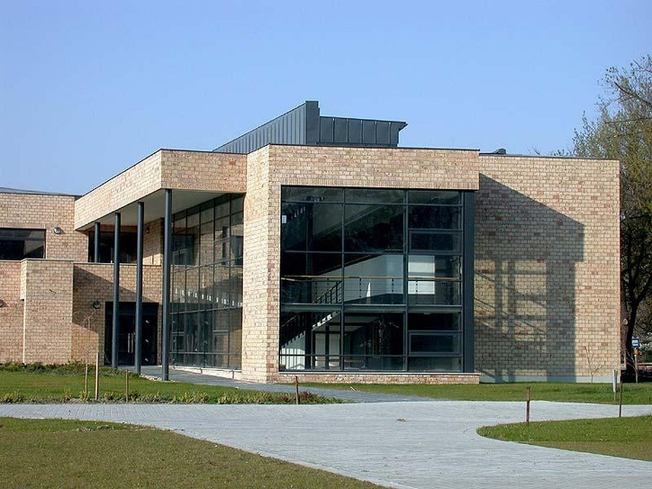

Programme

09:00 Evaluation of quality and production and raw materials with specific technological properties
Lecturer: Dr. Stanislav Baxa, NPPC VÚP Biocenter, Slovakia
10:00 Planning of sustainable nutrient supply during cultivation of plants
Lecturer: Dr. Renátó Kalocsai, Széchenyi István University of Győr, Hungary

Professional discussions, debate

Online connection at the link below:

Meeting ID: meet.google.com/yzb-jpsh-zfh

Attendance sheet for online participants:

https://forms.gle/fz43Vkngk5dn7bbq7

