Press release
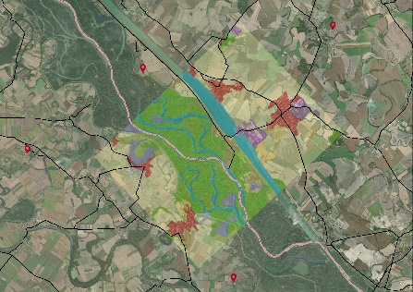
Within the framework of the TP LAB project, a GIS data and service center will be established for the wider area of Szigetköz (Malý Žitný ostrov) and Žitný ostrov (Csallóköz) in cooperation with the Institute of Spatial Planning (IPP) and the Slovak Univerity of Technology in Bratislava (STU), West-Pannon Nonprofit Ltd. and the Lechner Knowledge Centre in Hungary. The aim is to improve communication and the availability of information online and the coordination of spatial planning and harmonization of decision-making between regions closely related to each other but are divided by the border
In the Bratislava and Győr region an exceptionally interesting phenomenon can be observed in recent decades: economic development and the development of urban agglomerations crossing national borders. The natural environment is even less affected by whether or not it is located on one side of the border or another. The neighboring Žitný ostrov (Csallóköz) in Slovakia and Szigetköz (Malý Žitný ostrov) in Hungary have considerable importance in both nature conservation and ecotourism. Both sides of the border area are rich in natural, cultural and landscape assets.
However, not only the values but the problems are similar as well. Some are related to water management and the sustainable use of natural resources, others to the development of suburbs (agglomeration), and the quality of the urban environment.
In the interests of harmonious territorial development, it is advantageous to coordinate the designation of target areas for development on both sides of the border. For this purpose, in October 2020, TP LAB (Territorial Planning Laboratory) project was started with the cooperation of two Slovak and two Hungarian institutions with expertise in spatial planning and information services. The project is supported by the Interreg VA Slovak-Hungarian Cooperation Program.
The area of interest in the 16-month project includes the counties of Bratislava and Trnava on the Slovak side and the county of Győr-Moson-Sopron on the Hungarian side.
Within the framework of the project a GIS data and information service centre will be established in order to enable better communication between local actors, access to information online and territorial coordination. All this contributes to a more balanced spatial structure and a stronger coherence between valuable natural areas and the urbanized landscape.
The main goals are:
- providing support for multi-level spatial planning, territorial decision-making, monitoring of territorial changes and supporting sectoral investments and real estate developments with a web service (GIS Data and Service Center),
- definition of the database and web service with a joint needs assessment,
- establishment of Living Labs, testing, monitoring and evaluating the web service for further development, and assisting users in using the web service; and
- informing, training and improving skills of local authorities, municipalities, investors, spatial planners, university students and non-governmental organizations.
TP LAB will hold a kick-off meeting for the partners on January 28, 2021 at 1 pm in the Ceremonial Hall of the Győr City Hall and online. The event will be preceded by a public press conference in the morning, at which the experts of the participating institutions will present the elements of the project, as well as the experiences and results of the Slovak-Hungarian cross-border cooperation thus far in short, 15-20 minute presentations.
The press and members of the public are welcome to participate in the event. You can apply to the event organizer Illés Viktória at the e-mail address viktoria.illes@westpannon.hu and on the mobile phone +36 30 746 7780.
For more information, visit the TP LAB website or facebook page.
The contents of this press release do not necessarily represent the official position of the European Union.

